EyeBot7 Robot

EyeBot7 Robot is a fully self-contained mobile robot, based a Raspberry Pi 3+ with touch screen LCD and an EyeBot7 daughterboard including an Atmel CPU. Included are:
- Robot chassis
- Two drive motors with encapsulated encoders
- Embedded controller Raspberry Pi
- 16GB SD card with pre-installed software
- Auxiliary IO-Controller EyeBot 7 with ATxmega128A1U CPU
- Touch screen LCD
- 3 x infrared PSD distance sensors from Sharp
- 1 x Pi digital camera
- Lithium Polymer battery
- Mains Charger
On the software side:
- RoBIOS mobile robot operating system and library
- EyeSim simulation system for Windows, MacOS or Linux

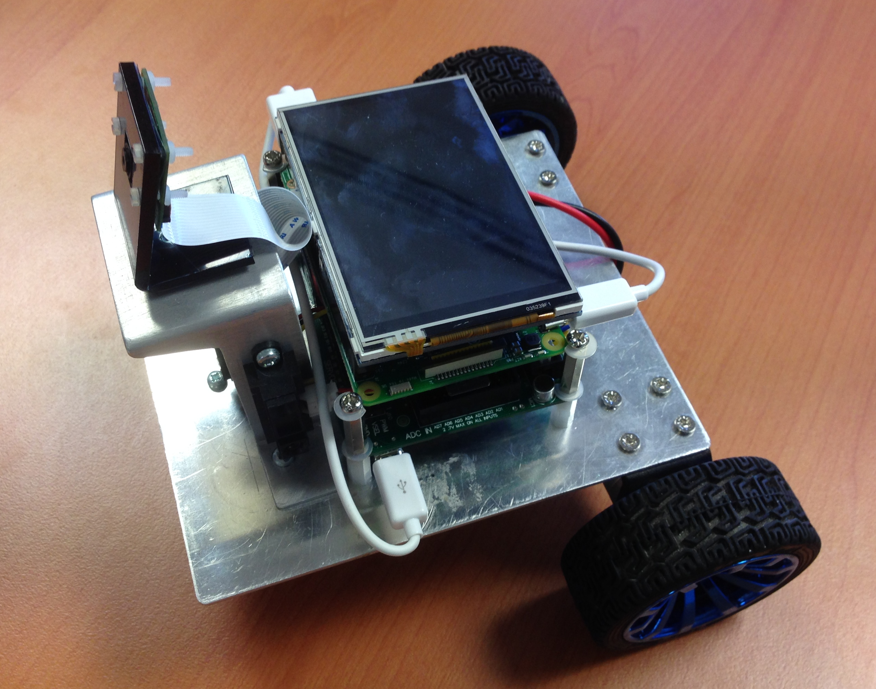

Robot design ptototype

Full Documentation

http://www.inrosoft.com/eyebot7/7r.pdf

